# [The Legend of Zelda] Site Plan

## [Yihan Zhang]

## WDD 130

## Overview

### Purpose

### This website aims to analyze and share the grand world view, exquisite game design and endless exploration fun of the "Legend of Zelda" series of games ("Breath of the Wild" and "Tears of the Kingdom"), and provide a place for visitors who want to play this game to learn more

### Audience

### Mainly for game enthusiasts who are looking for interesting games, want to understand real player experience, and want to view introductory tutorials.

## Branding

### Website Logo

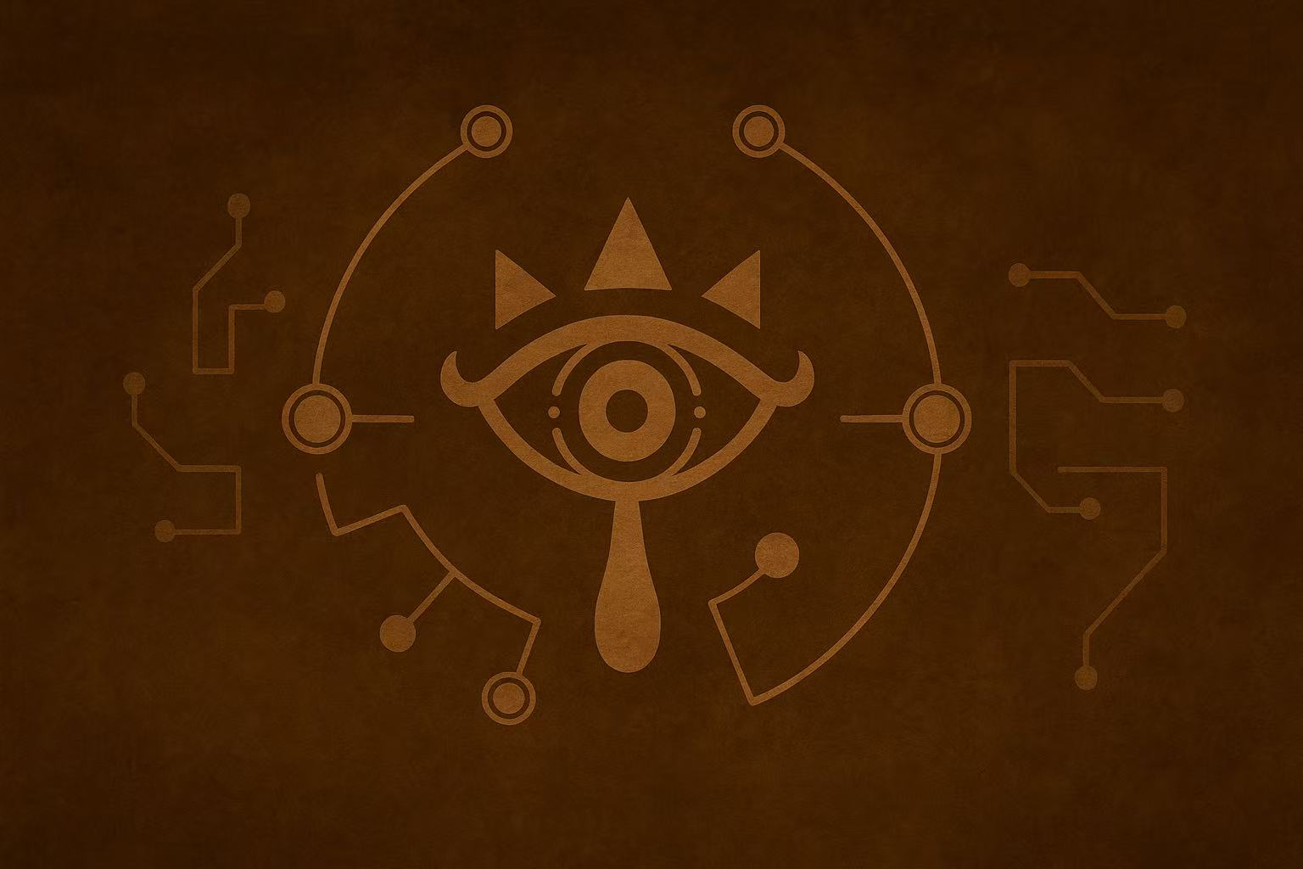

## Style Guide

### Color Palette

|  |  |  |  |
| --- | --- | --- | --- |
| **Primary** | **Secondary** | **Accent 1** | **Accent 2** |
| # 1a6bac | #3a7d4e | #4ac7d4 | #e6c35c |

### Typography

#### Heading Font: Cinzel

#### Paragraph Font: Merriweather/Lora

### Navigation

Home Breath of the Wild Tears of the Kingdom

**Content**

[put all content for the pages here, including written text and images]

**Home:**

***Title***: Explore the Boundless Hyrule

***Subtitle***: Step into the Legend That Redefined Open-World Gaming

***Introduction***:

This site is a tribute to “The Legend of Zelda: Breath of the Wild” and “Tears of the Kingdom”. These two titles are not only masterpieces within the series but also landmark achievements in the entire video game industry.

“Breath of the Wild”, with its unparalleled sense of freedom and exploration, garnered countless awards, including Game of the Year. It fundamentally reshaped the design of open worlds, creating a vibrant, living world for players worldwide to explore as they truly please.

Its sequel, “Tears of the Kingdom”, soared even higher from this foundation. Through systems like the “Ultrahand”, it elevated player freedom and creativity to unprecedented heights, earning widespread critical acclaim and being hailed as a marvel of modern gaming.

This site will guide you to the heart of these two legendary games, exploring how they made history and helping you write your own epic in Hyrule.

**Background image:**

**山上的风景

AI 生成的内容可能不正确。**

**Photo A：**

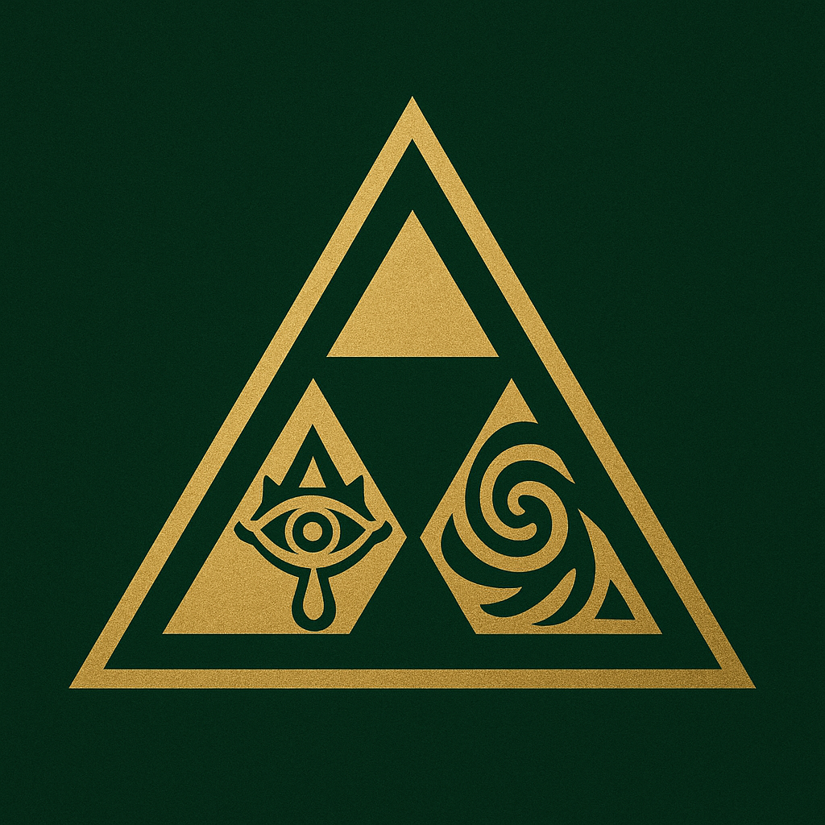

**Photo B：**

**徽标

AI 生成的内容可能不正确。**

**Breath of the Wild:**

**Game Introduction:**

This is an open-world action-adventure game. The story takes place 100 years after the downfall of the Hyrule Kingdom. A major disaster struck Hyrule Kingdom, causing its collapse. The protagonist Link awakens in an underground ruin and embarks on an adventure on the Hyrule continent, exploring ruins, unlocking temples, rescuing the four divine beasts, and restoring the Hyrule world that was damaged by the evil Ganon.

**Unique gameplay features**:

1. Vast Open World: Explore a massive, vibrant landscape with diverse terrains like grasslands, forests, and deserts.

2. Creative Puzzles: Solve unique challenges in temples using abilities like magnetism and time-stop to manipulate objects.

3. Strategic Combat: Employ different tactics against various enemies and upgrade your weapons and gear.

4. Dynamic Environment: Interact with the world following physics-based rules, where weather and your actions have tangible effects.

**Background image：**

**绿色的山

AI 生成的内容可能不正确。**

**Photo1：**

**图片包含 游戏机, 男人, 飞行, 模糊

AI 生成的内容可能不正确。**

**Photo2：**

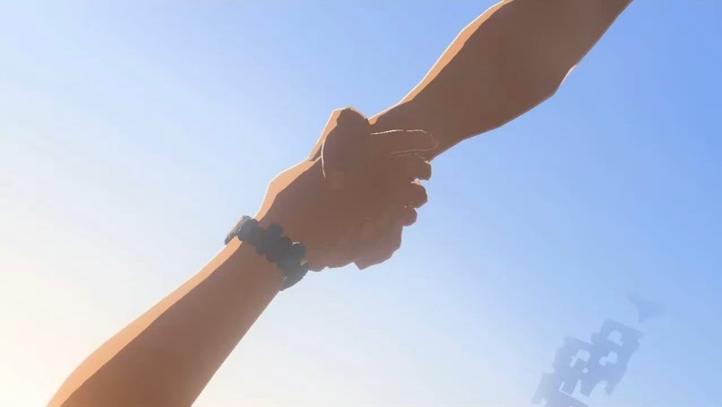

**Tears of the Kingdom:**

**Game Introduction:**

This is an open-world action-adventure game, the 20th installment of the "The Legend of Zelda" main series, and a sequel to "The Legend of Zelda: Breath of the Wild". The game is set in the Hyrule Kingdom. The player takes on the role of Link and needs to embark on adventures in the sky, on the ground, and underground, searching for the missing Zelda.

**Unique gameplay features:**

1.Retains most of the predecessor's systems, including interactive physics, puzzle-solving, and the weapon durability mechanic.

2.Enhanced Building System: Introduces features like "Fuse" and "Ultrahand" for combining materials and creating new weapons/tools.

3.New Abilities & Skills: Adds powers such as "Ascend" and "Recall," alongside "Sage Abilities" that assist in combat and puzzle-solving.

4.Expanded Map: Features a vastly larger world, including new sky islands and an extensive underground realm to explore.

**Background image：**

**图片包含 水, 男人, 海, 蛋糕

AI 生成的内容可能不正确。**

**Photo3:**

**地图

AI 生成的内容可能不正确。**

**Photo4:**

**水中的人在海上玩冲浪板的人们

AI 生成的内容可能不正确。**

**Wireframes**

### Home

### 形状 AI 生成的内容可能不正确。信件 AI 生成的内容可能不正确。

### 信件 AI 生成的内容可能不正确。